Module 3: Web Technologies
HTML Intro:
- HTML (Hypertext Markup Language) is the standard language used to create and design web pages.
- It tells the browser what content to display (text, images, links, videos) and how the content is structured, but not how it looks (that’s handled by CSS) or how it behaves (that’s handled by JavaScript).
HTML Structure’s Explanation:
<!DOCTYPE html>
<html>
<head>
<title>My First Web Page</title>
</head>
<body>
<h1>Hello World</h1>
<p>This is my first HTML page.</p>
</body>
</html>

1️⃣ <!DOCTYPE html>
- Tells the browser that this document is HTML5
- Helps the browser render the page correctly

2️⃣ <html>...</html>
- Root element of the HTML document
- All content must be inside this tag

3️⃣ <head>...</head>
Contains meta information (not visible on the page):
- Page title
- Character encoding
- CSS links
- SEO-related data

Example:
<head>
<title>Website Title</title>
</head>

4️⃣ <title>...</title>
- Displays the page title in the browser tab

5️⃣ <body>...</body>
- Contains all visible content
- Text, images, buttons, links, tables, forms, etc.
Example:
<body>
<h1>Main Heading</h1>
<p>This is a paragraph. </p>
</body>
Required HTML tags:
Tag | Purpose
<h1> to <h6> | Headings
<p> | Paragraph
<a> | Link
<img> | Image
<div> | Container
<span> | Inline container
<ul> / <ol> | Lists
<li> | List item
<table> Table create
<label> Form Inputs

CSS Into:
Overview of CSS and Its Importance in Web Design
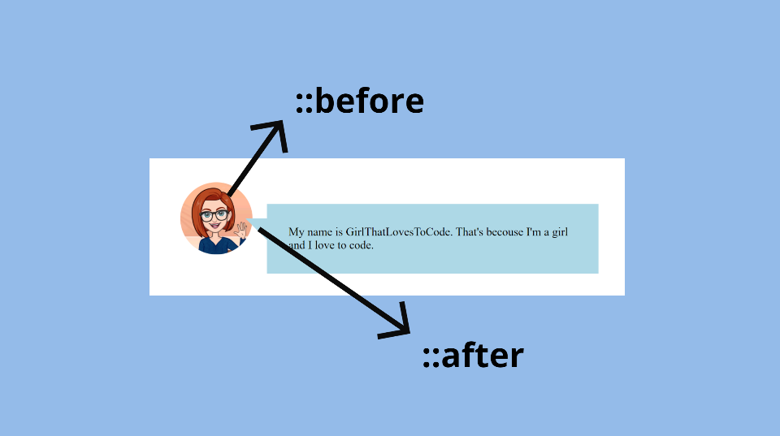
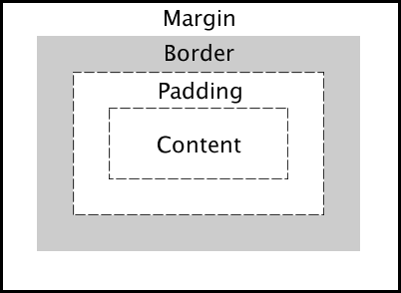
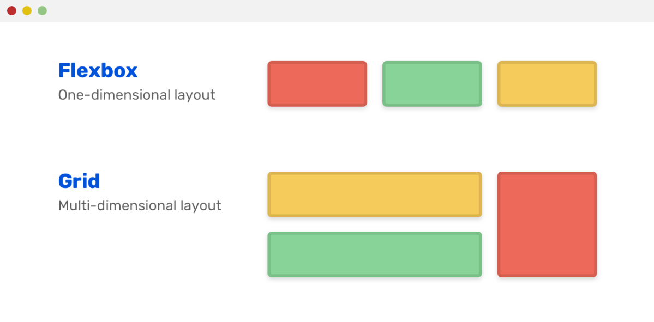

What is CSS?
CSS (Cascading Style Sheets) is a language used to style and design web pages.
While HTML defines the structure of a webpage, CSS controls how it looks—such as colors, fonts, spacing, layout, and animations.
In short:
HTML = Structure
CSS = Design & Appearance

🧩 Why CSS is Important in Web Design
1️⃣ Separates Content from Design
- HTML handles content
- CSS handles presentation
This makes websites cleaner, easier to maintain, and scalable
Example:
<h1>Welcome</h1>
h1 {
color: blue;
font-size: 32px;
}

2️⃣ Makes Websites Visually Attractive
CSS helps:
- Change colors and backgrounds
- Style text (fonts, size, alignment)
- Add shadows, borders, gradients
- Create animations and transitions
👉 A plain HTML page looks boring without CSS.

3️⃣ Enables Responsive Web Design
CSS allows websites to adjust for:
- Mobile phones 📱
- Tablets
- Laptops & desktops 💻
Using:
- Media queries
- Flexbox
- Grid system
Example:
@media (max-width: 768px) {
body {
background-color: lightgray;
}
}

4️⃣ Improves User Experience (UX)
Good CSS:
- Improves readability
- Creates proper spacing and alignment
- Makes navigation user-friendly
- Enhances accessibility

5️⃣ Saves Time and Effort
- One CSS file can style multiple pages
- Updating design in one place updates the entire site
Example:
button {
background-color: green;
}
➡ All buttons change automatically.

🛠️ Types of CSS
1️⃣ Inline CSS
Applied directly inside HTML tags
<p style="color:red;">Hello</p>
❌ Not recommended for large projects

2️⃣ Internal CSS
Written inside <style> tag in <head>
<style>
p { color: blue; }
</style>

3️⃣ External CSS (Best Practice ✅)
Written in a separate .css file
<link rel="stylesheet" href="style.css">
✔Clean
✔Reusable
✔ Professional
CSS: Margin and Padding
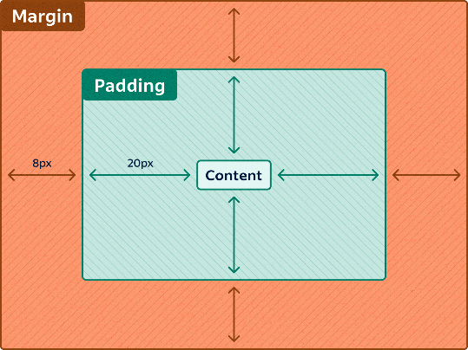
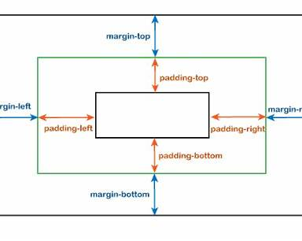
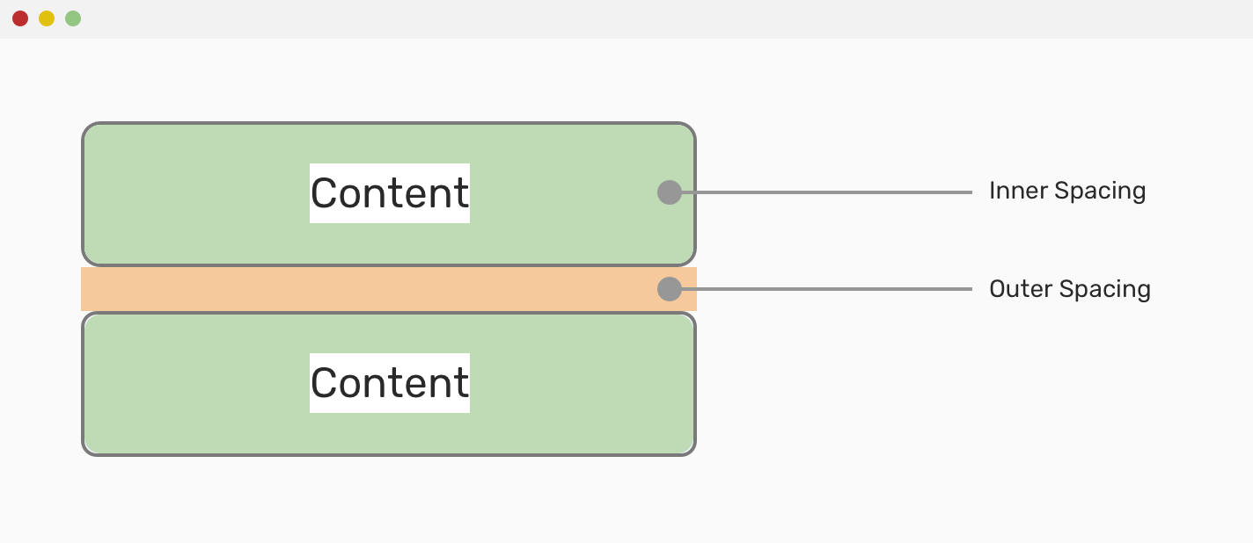

🔹 What is Margin in CSS?
Margin is the space outside an HTML element’s border.
👉 Purpose of Margin
- Creates distance between elements
- Controls how far an element is from other elements
- Does not affect the element’s background
Example:
.card {
margin: 20px;
}
✔ Adds 20px space around the element

🔹 What is Padding in CSS?
Padding is the space inside the element, between the content and the border.
👉 Purpose of Padding
- Creates breathing space inside the element
- Improves readability and UI
- Padding area is affected by background color
Example:
.card {
padding: 20px;
}
✔ Adds space between content and border

🔁 Key Difference: Margin vs Padding
Feature | Margin | Padding
Space Location | Outside the element | Inside the element
Affects background | ❌ No | ✅ Yes
Controls distance | Between elements | Between content & border
Used for | Layout spacing | Content spacing

Introduction to CSS Pseudo-Classes
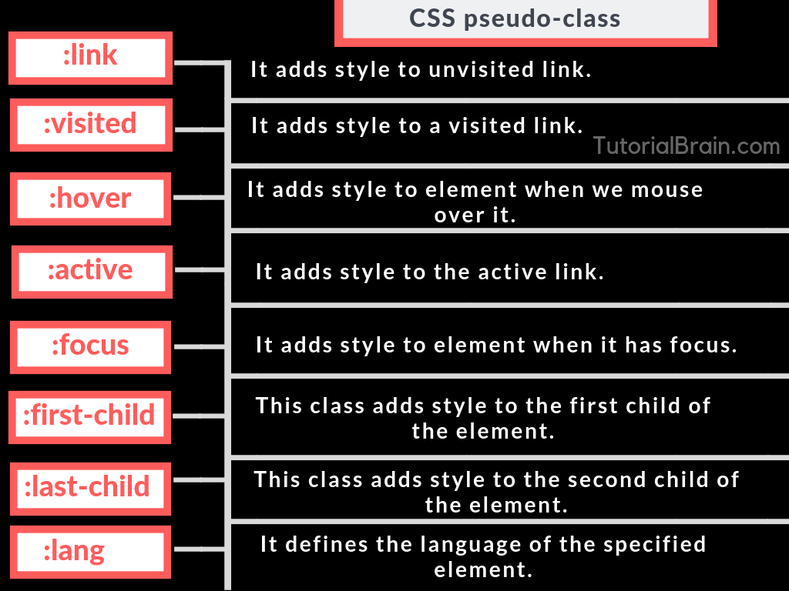
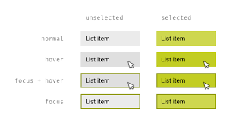
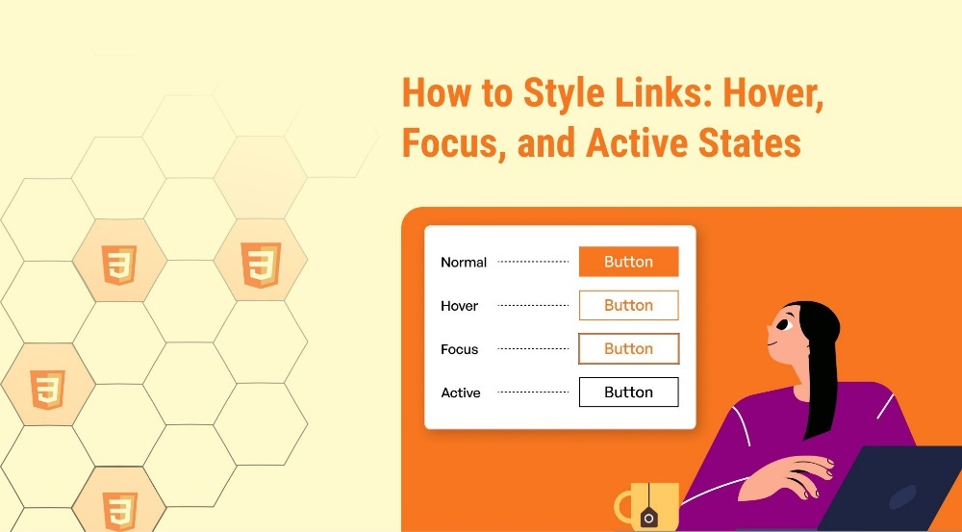

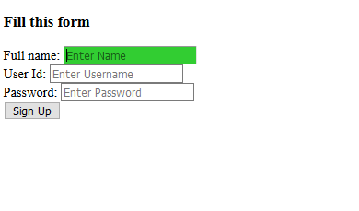

🔹 What are CSS Pseudo-Classes?
CSS pseudo-classes are keywords added to selectors that allow you to style elements based on their state or user interaction, without using JavaScript.
📌 Syntax:
selector:pseudo-class {
property: value;
}

🔑 Why Pseudo-Classes are Important
- Improve user interaction feedback
- Enhance UX & accessibility
- Allow dynamic styling without JavaScript
- Essential for modern, responsive UI design

🧩 Commonly Used CSS Pseudo-Classes

1️⃣: hover
Applied when the user moves the mouse over an element
Example:
button:hover {
background-color: green;
color: white;
}
✔ Used for buttons, links, cards
✔ Indicates interactivity

2️⃣: focus
Applied when an element receives focus (clicked or accessed via keyboard)
Example:
input:focus {
border: 2px solid blue;
outline: none;
}
✔ Important for forms & accessibility
✔ Helps keyboard navigation

3️⃣: active
Applied when an element is being clicked (mouse button down)
Example:
button:active {
transform: scale(0.95);
}
✔ Creates a pressed-button effect

4️⃣: visited
Styles links that have already been visited
a:visited {
color: purple;
}

5️⃣: link
Styles links that have not yet been visited
a:link {
color: blue;
}

6️⃣:disabled
Styles disabled input fields or buttons
button:disabled {
background-color: gray;
cursor: not-allowed;
}

7️⃣: checked
Applies to checked checkboxes or radio buttons
input:checked {
outline: 2px solid green;
}

🔁 Pseudo-Class Order (Important ❗)
For links, follow this order:
:link → :visited → :hover → :active
🔹 Remember as LVHA

🧪 Practical Example (Multiple States)
input {
border: 1px solid #ccc;
}

input:hover {
border-color: orange;
}

input:focus {
border-color: blue;
}

button:hover {
background-color: darkgreen;
}

button:active {
background-color: green;
}

Difference between id and class in CSS
Key Differences: id vs class
Feature | id | class
Uniqueness | Unique (one element) | Reusable (many elements)
CSS Selector | #idName | .className
Specificity | Higher | Lower
JavaScript usage | Often used | Often used
Reusability | ❌ No | ✅ Yes

📌 Usage Scenarios
✅ When to Use id
- Page sections (header, footer, navbar)
- Elements needing unique behavior
- JavaScript DOM access (getElementById)
- Anchor links
Example:
<section id="contact"></section>

✅ When to Use class
- Styling multiple elements the same way
- Buttons, cards, alerts, forms
- Responsive layouts
- Utility styles (spacing, colors)
Example:
<button class="btn primary">Submit</button>

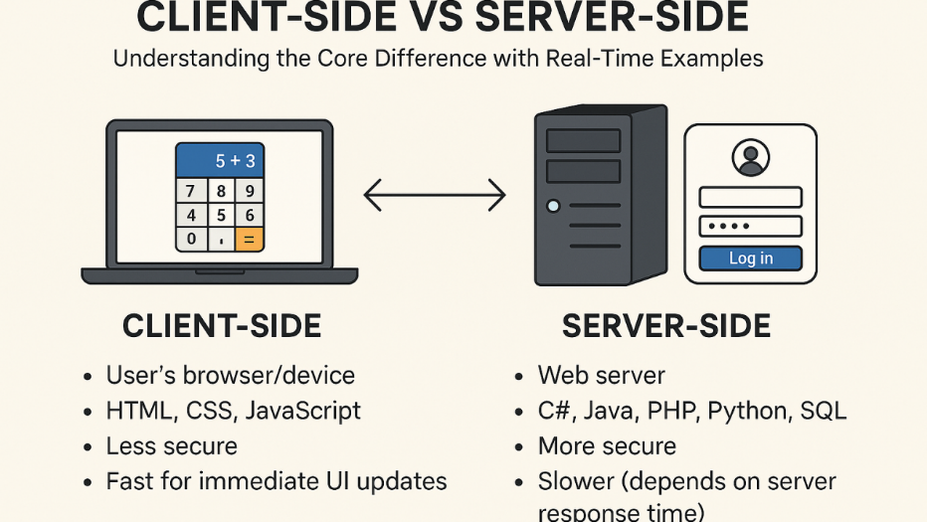
client-server architecture

Difference between client-side and server-side processing
Feature | Client-Side Processing | Server-Side Processing
Location | Client’s device | Server machine
Technologies | HTML, CSS, JavaScript | Java, Spring Boot, Node.js
Speed | Faster (no network call) | Slower (network dependent)
Security | Less secure | More secure
Data access | No direct DB access | Full DB access
Used for | UI, validation, effects | Business logic, data handling
Roles of a client, server, and communication protocols.
Common Protocols:
- HTTP / HTTPS → Web communication
- FTP → File transfer
- SMTP → Email sending
- WebSocket → Real-time communication
Introduction to the HTTP Protocol & Its Role in Web Communication
HTTP (HyperText Transfer Protocol) is the core communication protocol of the World Wide Web.
It defines how a client (browser/app) and a server communicate with each other.
Role of HTTP in Web Communication
HTTP is responsible for:
- Sending requests from client to server
- Receiving responses from server to client
- Transferring web resources (HTML, CSS, JS, images, JSON, etc.)
📌 HTTP follows a request–response model:
Client → HTTP Request → Server
Client ← HTTP Response ← Server

🔁 Key Characteristics of HTTP
- Stateless: Each request is independent
- Text-based: Easy to read and debug
- Extensible: Headers allow extra information
- Client–Server based

📤 HTTP Request
An HTTP request is sent by the client to ask for data or perform an action.
🔹 Components of an HTTP Request
- Request Line
- Request Headers
- Request Body (optional)
What is J2EE?
J2EE (Java 2 Enterprise Edition) — now known as Jakarta EE — is a Java platform used to build large-scale, enterprise-level, secure, and scalable web applications.
It provides:
- Standard APIs
- Predefined architecture
- Component-based development
- Strong support for web & distributed applications
📌 J2EE is widely used in banking, e-commerce, ERP, and enterprise systems.

🧩 What is Multi-Tier Architecture?
A multi-tier architecture divides an application into separate layers, where each layer has a specific responsibility.
This improves:
- Scalability
- Maintainability
- Security
- Performance

🏗️ J2EE Multi-Tier Architecture Overview
Commonly used 3-Tier Architecture:
Client Tier
↓
Web Tier
↓
Business (Application) Tier
↓
Data (Database) Tier

🔸 1️⃣ Client Tier
The client tier is the user interface layer.
Responsibilities:
- Interacts with the user
- Sends requests to the server
- Displays responses
Examples:
- Web browsers (HTML, CSS, JavaScript)
- Mobile apps
- Desktop clients

🔸 2️⃣ Web Tier (Web Container)
The Web Tier handles HTTP requests and responses.
Web Container Role:
A web container is responsible for managing web components.
Web Components:
- Servlets
- JSP (JavaServer Pages)
- Filters
- Listeners
Responsibilities of Web Container:
- Request routing
- Session management
- Security handling
- Lifecycle management of servlets & JSPs
📌 Example:
Browser → Servlet → Application Server

🔸 3️⃣ Business Tier (Application Server)
The Business Tier contains the core business logic.
Application Server Role:
An application server provides an environment to run business components.
Business Components:
- Enterprise JavaBeans (EJB)
- Services
- Transaction logic
- Security logic
Responsibilities:
- Business rules processing
- Transaction management
- Authentication & authorization
- Load balancing & scalability
📌 Examples of Application Servers:
- Apache Tomcat (web container + limited app server)
- JBoss / WildFly
- WebLogic
- WebSphere

🔸 4️⃣ Data Tier (Database Server)
The Data Tier manages application data.
Database Server Role:
- Stores data permanently
- Executes queries
- Maintains data integrity
Examples:
- MySQL
- Oracle
- PostgreSQL
Responsibilities:
- Data storage & retrieval
- Backup & recovery
- Security & indexing

🔁 End-to-End Request Flow (Example)
- User clicks Login on browser
- Request goes to Servlet (Web Container)
- Servlet calls Business Logic (Application Server)
- Business logic queries Database Server
- Data is returned → Servlet → Browser

📌 Why J2EE Multi-Tier Architecture is Important
- Clear separation of concerns
- Easy to scale individual layers
- Better security
- Team-friendly development
- Enterprise-ready architecture
🔹 What is CGI?
CGI (Common Gateway Interface) is a standard protocol that allows a web server to execute external programs (called CGI scripts) and generate dynamic web content in response to client requests.
📌 In simple terms:
CGI connects a web browser with server-side programs

🧩 Why CGI Was Needed
Originally, websites were static (HTML only).
CGI made it possible to:
- Process form data
- Access databases
- Generate dynamic pages
- Perform server-side logic
CGI scripts can be written in:
- C / C++
- Perl
- Python
- Shell scripts

🔁 CGI Working Process (Step-by-Step)
1️⃣ User sends a request (e.g., submits a form)
2️⃣ Web server detects it as a CGI request
3️⃣ Server executes the CGI program
4️⃣ CGI program processes input
5️⃣ CGI program generates output (HTML/text)
6️⃣ Server sends the response back to the browser
📌 Flow:
Browser → Web Server → CGI Script → Web Server → Browser

🧪 Example Scenario (Form Submission)
- User submits login form
- Web server runs login.cgi
- Script checks credentials
- Response page (success/failure) is returned

🟢 Advantages of CGI Programming
1️⃣ Language Independent
- CGI scripts can be written in any programming language

2️⃣ Simple and Standardized
- Easy to understand
- Works with most web servers

3️⃣ Dynamic Content Generation
- Enables form handling
- Database access
- User-based responses

4️⃣ Platform Independent
- Same CGI logic works across systems with minor changes

🔴 Disadvantages of CGI Programming
1️⃣ Poor Performance ❌
- New process is created for every request
- High memory and CPU usage

2️⃣ Scalability Issues
- Not suitable for high-traffic applications
- Server overload under multiple requests

3️⃣ Security Risks
- Improper input validation can lead to attacks
- Exposed scripts can be misused

4️⃣ Maintenance Complexity
- Harder to manage large CGI-based applications
- Less structured than modern frameworks

⚖️ CGI vs Modern Server-Side Technologies
Feature | CGI | Modern Frameworks
Performance | Low | High
Scalability | Poor | Excellent
Architecture | Script-based | Multi-tier / MVC
Use Today | Rare | Widely used

📌 Why CGI Is Rarely Used Today
CGI has been largely replaced by:
- Servlets
- JSP
- PHP
- ASP.NET
- Spring Boot
- Node.js
These technologies:
✔ Reuse processes
✔ Handle concurrency efficiently
✔ Are more secure & scalable
🔹 What is a Servlet?
A Servlet is a server-side Java component used to create dynamic web applications.
Servlets run inside a web container (like Tomcat) and handle client requests and server responses using the HTTP protocol.
📌 In simple words:
Servlet = Java program that runs on a server and responds to web requests

🧩 Why Servlets Are Used
Servlets allow developers to:
- Process form data
- Handle business logic
- Interact with databases
- Generate dynamic HTML or JSON responses
They are a core part of Java web development and the foundation for technologies like JSP and Spring MVC.

🔁 How Servlets Work (Step-by-Step)
1️⃣ User sends an HTTP request from browser
2️⃣ Web server forwards request to Web Container
3️⃣ Web container finds the correct Servlet
4️⃣ Servlet processes the request
5️⃣ Servlet generates a response
6️⃣ Web container sends response back to browser
📌 Flow:
Browser → Web Server → Web Container → Servlet
Servlet → Web Container → Browser

🔄 Servlet Lifecycle
The servlet lifecycle is managed by the web container.
1️⃣ init()
- Called once when servlet is loaded
- Used for initialization
2️⃣ service()
- Called for every request
- Delegates to doGet(), doPost(), etc.
3️⃣ destroy()
- Called once before servlet is removed
- Used for cleanup

🧪 Simple Servlet Example
import jakarta.servlet.*;
import jakarta.servlet.http.*;
import java.io.*;

public class HelloServlet extends HttpServlet {
protected void doGet(HttpServletRequest req, HttpServletResponse res)
throws IOException {
res.setContentType("text/html");
PrintWriter out = res.getWriter();
out.println("<h1>Hello from Servlet</h1>");
}
}

🟢 Advantages of Servlets
1️⃣ Better Performance (Compared to CGI)
- Uses multi-threading
- No new process per request

2️⃣ Platform Independent
- Write once, run anywhere (Java)

3️⃣ Secure
- Runs inside JVM
- Strong support for authentication & authorization

4️⃣ Scalable
- Handles multiple users efficiently
- Used in enterprise-level applications

5️⃣ Integration with Java Ecosystem
- Easy integration with JDBC, JPA, Spring, etc.

🔴 Disadvantages of Servlets
1️⃣ Complex for UI Development
- Mixing Java code with HTML is hard to maintain

2️⃣ Requires Java Knowledge
- Not beginner-friendly compared to PHP

3️⃣ More Boilerplate Code
- Requires configuration and lifecycle handling

4️⃣ Slower Development for Simple Apps
- Overkill for small or static websites

⚖️ Servlet vs Other Web Technologies
Feature | Servlet | CGI | PHP
Performance | High | Low | Medium
Scalability | High | Poor | Medium
Language | Java | Any | PHP
Thread-based | ✅ Yes | ❌ No | ❌ No
Enterprise use | ✅ Yes | ❌ No | ⚠️ Limited

📌 When to Use Servlets
✔ Large-scale applications
✔ Enterprise systems
✔ Secure and scalable apps
✔ Backend APIs
📜 History of Servlet Versions
Servlet technology has evolved along with Java Enterprise (J2EE → Java EE → Jakarta EE) to improve performance, security, and developer productivity.

🔹 Major Servlet Versions (Overview)
Servlet Version | Java EE / Jakarta EE | Key Highlights
Servlet 1.0 (1997) | JDK 1.1 | Basic servlet concept introduced
Servlet 2.0 | J2EE 1.2 | HTTP support, request/response model
Servlet 2.1 | J2EE 1.2 | Improved lifecycle, RequestDispatcher
Servlet 2.2 | J2EE 1.3 | Web application concept (web.xml)
Servlet 2.3 | J2EE 1.3 | Filters, listeners introduced
Servlet 2.4 | J2EE 1.4 | XML-based configuration
Servlet 2.5 | Java EE 5 | Annotations introduced
Servlet 3.0 | Java EE 6 | Async processing, no web.xml required
Servlet 3.1 | Java EE 7 | Non-blocking I/O
Servlet 4.0 | Java EE 8 | HTTP/2 support
Servlet 5.0+ | Jakarta EE | Package changed to jakarta.servlet
📌 Important Change
- Old package: javax.servlet.*
- New package: jakarta.servlet.*

🧠 Why Servlet Evolution Was Important
- Better performance
- Improved scalability
- Reduced boilerplate code
- Support for modern web standards
- Easier configuration with annotations

🧩 Types of Servlets
Servlets are mainly classified into two types based on their usage and protocol handling.

1️⃣ GenericServlet
🔹 What is GenericServlet?
GenericServlet is a protocol-independent servlet.
It can handle any type of request, not limited to HTTP.
🔹 Key Features
- Part of jakarta.servlet
- Abstract class
- Implements Servlet and ServletConfig
- Uses service() method only
🔹 Example:
import jakarta.servlet.*;
import java.io.*;

public class MyGenericServlet extends GenericServlet {
public void service(ServletRequest req, ServletResponse res)
throws IOException {
res.getWriter().println("Generic Servlet Response");
}
}
🔹 Use Case
- Non-HTTP based applications
- Rarely used in real-world web apps

2️⃣ HttpServlet
🔹 What is HttpServlet?
HttpServlet is a protocol-specific servlet designed specifically for HTTP requests.
🔹 Key Features
- Extends GenericServlet
- Located in jakarta.servlet.http
- Supports HTTP methods:
  - doGet()
  - doPost()
  - doPut()
  - doDelete()
🔹 Example:
import jakarta.servlet.http.*;
import java.io.*;
public class MyHttpServlet extends HttpServlet {
protected void doGet(HttpServletRequest req, HttpServletResponse res)
throws IOException {
res.getWriter().println("HTTP Servlet Response");
}
}
🔹 Use Case
✔ Web applications
✔ REST APIs
✔ Form handling
✔ Login & authentication

⚖️ GenericServlet vs HttpServlet
Feature | GenericServlet | HttpServlet
Protocol | Any | HTTP only
Package | jakarta.servlet | jakarta.servlet.http
Methods | service() | doGet(), doPost()
Usage | Rare | Very common
Web apps | ❌ | ✅
Feature-by-Feature Comparison
Feature | GenericServlet | HttpServlet
Protocol support | Protocol-independent | HTTP / HTTPS only
Package | jakarta.servlet | jakarta.servlet.http
Inheritance | Implements Servlet | Extends GenericServlet
Main method | service() | doGet(), doPost(), etc.
Request type | ServletRequest | HttpServletRequest
Response type | ServletResponse | HttpServletResponse
HTTP methods | ❌ Not supported | ✅ Supported
Cookies | ❌ No | ✅ Yes
Sessions | ❌ No | ✅ Yes
Headers handling | ❌ No | ✅ Yes
URL rewriting | ❌ No | ✅ Yes
Usage in real projects | Rare | Very common

How to Create Servlets and Configure Them Using web.xml
🧩 Step 1: Create a Servlet Class
Example: Simple Servlet
import jakarta.servlet.*;
import jakarta.servlet.http.*;
import java.io.IOException;
import java.io.PrintWriter;

public class HelloServlet extends HttpServlet {

@Override
protected void doGet(HttpServletRequest req, HttpServletResponse res)
throws ServletException, IOException {

res.setContentType("text/html");
PrintWriter out = res.getWriter();
out.println("<h1>Hello, Servlet World!</h1>");
}
}
🔸 Explanation
- extends HttpServlet → HTTP-specific servlet
- doGet() → handles GET requests
- HttpServletRequest → request data
- HttpServletResponse → response to client

🧩 Step 2: Configure Servlet Using web.xml
The web.xml file is called the deployment descriptor.
It tells the web container:
- Which servlet class to load
- Which URL should call which servlet
📌 Location:
WEB-INF/web.xml

📄 Sample web.xml Configuration
<web-app>

<!-- Servlet Definition -->
<servlet>
<servlet-name>HelloServlet</servlet-name>
<servlet-class>com.example.HelloServlet</servlet-class>
</servlet>

<!-- Servlet Mapping -->
<servlet-mapping>
<servlet-name>HelloServlet</servlet-name>
<url-pattern>/hello</url-pattern>
</servlet-mapping>

</web-app>

🔍 Explanation of web.xml Tags
<servlet>
Defines the servlet class.
<servlet>
<servlet-name>HelloServlet</servlet-name>
<servlet-class>com.example.HelloServlet</servlet-class>
</servlet>
- servlet-name → Logical name
- servlet-class → Fully qualified class name

<servlet-mapping>
Maps a URL to the servlet.
<servlet-mapping>
<servlet-name>HelloServlet</servlet-name>
<url-pattern>/hello</url-pattern>
</servlet-mapping>
➡ Access using:
http://localhost:8080/YourApp/hello

🔁 Servlet Request Flow (Using web.xml)
- User enters URL /hello
- Web container checks web.xml
- Finds matching url-pattern
- Loads HelloServlet
- Calls doGet() or doPost()
- Sends response to browser

🧪 Example: POST Method Servlet
@Override
protected void doPost(HttpServletRequest req, HttpServletResponse res)
throws IOException {

String name = req.getParameter("name");
res.getWriter().println("Welcome " + name);
}
HTML form:
<form action="hello" method="post">
<input type="text" name="name">
<button type="submit">Submit</button>
</form>

📌 Advantages of Using web.xml
- Centralized configuration
- Easy URL mapping
- Suitable for large enterprise apps
- No need to modify Java code for URL changes
What Are Logical URLs in Servlets?
A logical URL is a virtual URL pattern that maps to a servlet, instead of directly exposing the servlet class or file path.
📌 Example logical URL:
/login
📌 Physical class:
com.app.LoginServlet
👉 The browser sees /login, not the Java class name.

🧩 Why Logical URLs Are Used
- Security: Hides internal servlet class names
- Maintainability: Change servlet class without changing client URLs
- Clean URLs: Easy to read and remember
- Decoupling: URL is independent of implementation

🔁 Logical URL Mapping Using web.xml
<servlet>
<servlet-name>LoginServlet</servlet-name>
<servlet-class>com.app.LoginServlet</servlet-class>
</servlet>

<servlet-mapping>
<servlet-name>LoginServlet</servlet-name>
<url-pattern>/login</url-pattern>
</servlet-mapping>
✅ Access URL:
http://localhost:8080/MyApp/login
👉 /login is the logical URL

🧪 Logical URL in HTML Form
<form action="login" method="post">
<input type="text" name="user">
<input type="password" name="pass">
<button type="submit">Login</button>
</form>
- Client does NOT know the servlet class
- Web container handles mapping

🆚 Logical URL vs Physical URL
Aspect | Logical URL | Physical URL
Meaning | Virtual mapping | Actual file/class
Security | High | Low
Maintainability | Easy | Difficult
Recommended | ✅ Yes | ❌ No

📘 Overview of ServletConfig
🔹 What is ServletConfig?
ServletConfig is an interface that provides configuration information to a specific servlet.
- One ServletConfig object per servlet
- Created by the web container
- Used to read init parameters

🔁 Lifecycle Relationship
- Container creates ServletConfig
- Passes it to init(ServletConfig config)
- Servlet reads configuration values

🔧 Commonly Used Methods of ServletConfig
1️⃣ getInitParameter(String name)
Returns a specific initialization parameter value.
String dbName = config.getInitParameter("database");

2️⃣ getInitParameterNames()
Returns all init parameter names.
Enumeration<String> names = config.getInitParameterNames();

3️⃣ getServletName()
Returns the servlet’s logical name.
String name = config.getServletName();

4️⃣ getServletContext()
Returns ServletContext object (shared across app).
ServletContext ctx = config.getServletContext();

🧩 ServletConfig Example Using web.xml
web.xml
<servlet>
<servlet-name>LoginServlet</servlet-name>
<servlet-class>com.app.LoginServlet</servlet-class>

<init-param>
<param-name>database</param-name>
<param-value>users_db</param-value>
</init-param>

</servlet>

Servlet Code
public void init(ServletConfig config) {
String db = config.getInitParameter("database");
System.out.println("DB Name: " + db);
}

📌 When to Use ServletConfig
- Servlet-specific configuration
- Database names
- File paths
- API keys (non-sensitive)

🆚 ServletConfig vs ServletContext (Quick Look)
Feature | ServletConfig | ServletContext
Scope | One servlet | Whole application
Object count | One per servlet | One per app
Used for | Local config | Shared config
🔁 RequestDispatcher in Servlets: forward() and include()
What is RequestDispatcher?
RequestDispatcher is a servlet interface used to transfer a request from one resource to another on the same server.
📌 Resources can be:
- Another Servlet
- JSP
- HTML file
It allows server-side navigation without informing the client (browser).

📥 How to Get RequestDispatcher
RequestDispatcher rd = request.getRequestDispatcher("target.jsp");
or
RequestDispatcher rd = request.getRequestDispatcher("/login");

🔹 forward() Method
👉 What does forward() do?
- Transfers control completely to another resource
- The original resource stops execution
- Client sees same URL
Syntax:
rd.forward(request, response);

🔁 Flow of forward()
Client → Servlet A → forward() → Servlet B/JSP → Client

Example: Using forward()
RequestDispatcher rd = request.getRequestDispatcher("welcome.jsp");
rd.forward(request, response);
📌 Use Case:
- Login validation
- Page redirection based on logic
- MVC controller flow

🔹 include() Method
👉 What does include() do?
- Includes output of another resource
- The original servlet continues execution
- Useful for reusable components
Syntax:
rd.include(request, response);

🔁 Flow of include()
Client → Servlet → include() → Another Resource → Back to Servlet → Client

Example: Using include()
out.println("<h1>Main Page</h1>");
RequestDispatcher rd = request.getRequestDispatcher("footer.jsp");
rd.include(request, response);
📌 Use Case:
- Header/Footer
- Navigation bars
- Common layout sections

⚖️ Difference Between forward() and include()
Feature | forward() | include()
Control transfer | Full | Partial
Execution of caller | Stops | Continues
URL change in browser | ❌ No | ❌ No
Response output | Only target | Combined output
Common use | Navigation | Reusable content

📌 Important Points
- Works only inside the server
- Same request & response objects shared
- Cannot forward after response is committed
- Faster than client-side redirect

Feature | forward() | sendRedirect()
Server/Client side | Server-side | Client-side
URL change | ❌ No | ✅ Yes
Performance | Fast | Slower
🆚 Forward vs SendRedirect (Quick Note)

🔹 What is ServletContext?
ServletContext is an interface that represents the entire web application.
It is created once when the application starts and destroyed when the application stops.
📌 In simple words:
ServletContext = Shared memory and configuration for the whole web app

🧩 Scope of ServletContext
- Application scope
- Shared among all servlets, JSPs, and filters
- One ServletContext object per web application
🔁 Lifecycle
Application Start → ServletContext Created
Application Stop → ServletContext Destroyed

🛠️ Common Uses of ServletContext
- Share data between servlets
- Read global configuration parameters
- Access resources (files, paths)
- Track application-level counters/logs

🔧 Important Methods of ServletContext
1️⃣ setAttribute() / getAttribute()
Share data across the application.
ServletContext ctx = getServletContext();
ctx.setAttribute("appName", "Student Portal");
String name = (String) ctx.getAttribute("appName");

2️⃣ getInitParameter()
Reads global parameters from web.xml.
String admin = ctx.getInitParameter("adminEmail");

3️⃣ getRealPath()
Gets actual server path.
String path = ctx.getRealPath("/images/logo.png");

📄 ServletContext Configuration in web.xml
<context-param>
<param-name>adminEmail</param-name>
<param-value>admin@example.com</param-value>
</context-param>
✔ Accessible by all servlets

🆚 ServletContext vs ServletConfig (Quick Comparison)
Feature | ServletContext | ServletConfig
Scope | Whole application | Single servlet
Object count | One per app | One per servlet
Used for | Global data | Servlet-specific data
Shared | ✅ Yes | ❌ No

🔔 Web Application Listeners
🔹 What are Web Application Listeners?
Listeners are Java classes that listen to lifecycle events of:
- Web application
- Session
- Request
They allow you to execute code automatically when events occur.

🔁 Common Lifecycle Events
- Application start
- Application shutdown
- Session creation/destruction
- Attribute changes

🧩 ServletContextListener (Most Important)
🔹 What does it do?
ServletContextListener listens for:
- Application startup
- Application shutdown

🛠️ Methods of ServletContextListener
1️⃣ contextInitialized()
Called when the application starts.
public void contextInitialized(ServletContextEvent sce) {
System.out.println("Application Started");
}

2️⃣ contextDestroyed()
Called when the application stops.
public void contextDestroyed(ServletContextEvent sce) {
System.out.println("Application Stopped");
}

🧪 Example: Web Application Listener
import jakarta.servlet.*;

public class AppListener implements ServletContextListener {

public void contextInitialized(ServletContextEvent sce) {
ServletContext ctx = sce.getServletContext();
ctx.setAttribute("appStartTime", System.currentTimeMillis());
System.out.println("App initialized");
}

public void contextDestroyed(ServletContextEvent sce) {
System.out.println("App destroyed");
}
}

🧩 Listener Configuration
Using web.xml
<listener>
<listener-class>com.app.AppListener</listener-class>
</listener>
Using Annotation (Servlet 3.0+)
@WebListener
public class AppListener implements ServletContextListener {
}

📌 Real-World Use Cases
- Initializing database connections
- Loading configuration files
- Application-wide logging
- Cleanup before shutdown
🔹 What is a Filter in Java?
A Filter is a Java component that intercepts HTTP requests and responses before they reach a servlet and after they leave it.
📌 In simple terms:
Filter = Pre-processing and post-processing layer for requests and responses
Filters are part of the Servlet API and run inside the web container.

🧩 When Are Filters Needed?
Filters are used when you want to apply common logic across multiple servlets or requests.
Common Use Cases
- ✅ Authentication & authorization
- ✅ Logging and auditing
- ✅ Input validation
- ✅ Data compression
- ✅ CORS handling
- ✅ Character encoding

🔁 How Filters Work (Request Flow)
Client
↓
Filter(s)
↓
Servlet / JSP
↓
Filter(s)
↓
Client
➡ Multiple filters can form a filter chain.

🧠 Filter Lifecycle
The web container manages the lifecycle of filters.
1️⃣ init()
- Called once when filter is created
- Used for initialization
public void init(FilterConfig config) {
System.out.println("Filter Initialized");
}

2️⃣ doFilter()
- Called for every request
- Contains main logic
- Decides whether to continue the chain
public void doFilter(ServletRequest req, ServletResponse res,
FilterChain chain)
throws IOException, ServletException {

System.out.println("Before Servlet");
chain.doFilter(req, res); // passes request to next filter/servlet
System.out.println("After Servlet");
}

3️⃣ destroy()
- Called once before filter is removed
- Cleanup logic
public void destroy() {
System.out.println("Filter Destroyed");
}

🧪 Example: Simple Filter
import jakarta.servlet.*;
import java.io.IOException;

public class LogFilter implements Filter {

public void init(FilterConfig config) {
System.out.println("LogFilter init");
}

public void doFilter(ServletRequest req, ServletResponse res,
FilterChain chain)
throws IOException, ServletException {

System.out.println("Request received");
chain.doFilter(req, res);
System.out.println("Response sent");
}

public void destroy() {
System.out.println("LogFilter destroy");
}
}

⚙️ Configuring Filters Using web.xml
📄 web.xml configuration:
<filter>
<filter-name>LogFilter</filter-name>
<filter-class>com.app.LogFilter</filter-class>
</filter>

<filter-mapping>
<filter-name>LogFilter</filter-name>
<url-pattern>/*</url-pattern>
</filter-mapping>

🔍 Explanation of Tags
- <filter> → defines filter class
- <filter-mapping> → decides which requests the filter applies to
- /* → filter applies to all URLs

🧩 URL Pattern Examples
Pattern | Applies To
/* | All requests
/login | Only login URL
/admin/* | All admin URLs
*.jsp | All JSP pages

🆚 Filter vs Servlet
Feature | Filter | Servlet
Main role | Intercept | Process request
Executes | Before & after | Main processing
Controls flow | Yes | No
Used for | Cross-cutting concerns | Business logic

📌 Important Notes
- Filters must call chain.doFilter() to continue processing
- Order of filters matters
- Filters do NOT generate responses directly (mostly)
🔹 What is JSP?
JSP (JavaServer Pages) is a server-side Java technology used to create dynamic web pages.
It allows you to embed Java logic within HTML to generate content dynamically.
📌 In simple terms:
Servlet = Java code first
JSP = HTML first (with Java support)
JSP is built on top of Servlets—every JSP is eventually translated into a servlet by the web container.

🧩 Why JSP is Used
- Simplifies UI development
- Separates presentation from business logic
- Easy integration with Servlets
- Ideal for MVC (View layer)

🔁 How JSP Works (Brief Flow)
- Client requests a .jsp page
- Web container converts JSP → Servlet
- Servlet compiles & executes
- Response (HTML) sent to browser

🔑 Key Components of JSP

1️⃣ Scriptlets
🔹 What are Scriptlets?
Scriptlets allow Java code to be written directly inside JSP pages.
Syntax:
<%
int x = 10;
out.println(x);
%>
🔸 Types of Scripting Elements
- Scriptlet: <% %>
- Expression: <%= %>
- Declaration: <%! %>
⚠️ Note
❌ Scriptlets are not recommended in modern JSP
✔ Use JSTL and EL instead

2️⃣ Implicit Objects
🔹 What are Implicit Objects?
Implicit objects are predefined objects provided by the JSP container—no need to create them.
🔹 Common JSP Implicit Objects
Object | Purpose
request | Client request data
response | Response to client
session | Session data
application | App-wide data
out | Output stream
pageContext | Page-level info
config | Servlet config
page | Current JSP page
exception | Error handling
Example:
User Agent: <%= request.getHeader("User-Agent") %>

3️⃣ JSTL (JavaServer Pages Standard Tag Library)
🔹 What is JSTL?
JSTL provides custom tags to perform common tasks without writing Java code.
✔ Cleaner
✔ Readable
✔ Recommended

🔹 Common JSTL Tags
Core Tags (c)
<c:if test="${age > 18}">
You are eligible
</c:if>
<c:forEach var="i" begin="1" end="5">
${i}<br>
</c:forEach>
URL & Redirect
<c:redirect url="login.jsp"/>

4️⃣ Custom Tags
🔹 What are Custom Tags?
Custom tags allow developers to create their own reusable JSP tags.
📌 Used to:
- Encapsulate complex logic
- Improve code reuse
- Keep JSP clean

🔹 Example (Concept)
<mytags:header title="Welcome"/>
✔ Logic handled in Java
✔ JSP remains clean
Custom tags are defined using:
- Tag Handler classes
- Tag Library Descriptor (TLD) files

Feature | Scriptlets | JSTL
Java code in JSP | Yes | No
Readability | Poor | Excellent
Recommended | ❌ No | ✅ Yes
MVC friendly | ❌ | ✅
🆚 Scriptlets vs JSTL (Important Comparison)

🔹 What is Session Management?
Session management is the process of maintaining user state across multiple HTTP requests.
📌 Why it’s needed:
- HTTP is stateless
- Server does not remember users between requests
- Sessions help track users (login, cart, preferences)

🧩 Common Session Management Techniques
1️⃣ Cookies
2️⃣ Hidden Form Fields
3️⃣ URL Rewriting
4️⃣ HttpSession (Server-side Sessions)

1️⃣ Cookies
🔹 What are Cookies?
Cookies are small text files stored on the client’s browser.
🔸 How They Work
- Server sends cookie → browser stores it
- Browser sends cookie with every request
Example:
Cookie c = new Cookie("user", "Trush");
response.addCookie(c);
Cookie[] cookies = request.getCookies();
✅ Advantages
- Simple to use
- Automatic with each request
❌ Disadvantages
- Less secure
- Can be disabled by user
- Size limit (~4KB)

2️⃣ Hidden Form Fields
🔹 What are Hidden Form Fields?
Hidden values are stored in HTML forms using hidden inputs.
<input type="hidden" name="userId" value="101">
🔸 How They Work
- Data travels with form submission
- Server retrieves values via request parameters
String userId = request.getParameter("userId");
✅ Advantages
- Simple
- No browser dependency
❌ Disadvantages
- Works only with forms
- Not secure
- Not suitable for large data

3️⃣ URL Rewriting
🔹 What is URL Rewriting?
Session data is appended to the URL as parameters.
/dashboard;jsessionid=AB123
or
dashboard?userId=101
Example:
String url = response.encodeURL("home.jsp");
✅ Advantages
- Works when cookies are disabled
❌ Disadvantages
- URLs look messy
- Security risk (data visible in URL)
- Bookmarking issues

4️⃣ HttpSession (Server-Side Sessions)
🔹 What is HttpSession?
HttpSession stores session data on the server side.
🔸 How It Works
- Server creates a session ID
- Session ID stored in cookie (usually JSESSIONID)
- Server maps session ID → user data
Example:
HttpSession session = request.getSession();
session.setAttribute("username", "Trush");
String user = (String) session.getAttribute("username");
✅ Advantages
- Secure (data on server)
- Can store complex objects
- Most widely used
❌ Disadvantages
- Uses server memory
- Requires session timeout handling

⚖️ Comparison of Session Management Techniques
Technique | Stored At | Security | Best Use Case
Cookies | Client | Low | Remember user
Hidden Fields | Client (form) | Low | Short form flows
URL Rewriting | URL | Low | Cookies disabled
HttpSession | Server | High | Login, carts

🧭 How to Track User Sessions in Web Applications
🔹 Standard Session Tracking Flow
1️⃣ User sends request
2️⃣ Server creates HttpSession
3️⃣ Server assigns Session ID
4️⃣ Browser stores session ID (cookie)
5️⃣ Each request sends session ID
6️⃣ Server identifies the user

🧪 Session Tracking Example (Login Scenario)
HttpSession session = request.getSession();
session.setAttribute("isLoggedIn", true);
Later:
Boolean status = (Boolean) session.getAttribute("isLoggedIn");
if(status == null) {
response.sendRedirect("login.jsp");
}

⏳ Session Timeout
<session-config>
<session-timeout>30</session-timeout>
</session-config>

